L i f e w a y s 2 0 2 2

Bridging the River
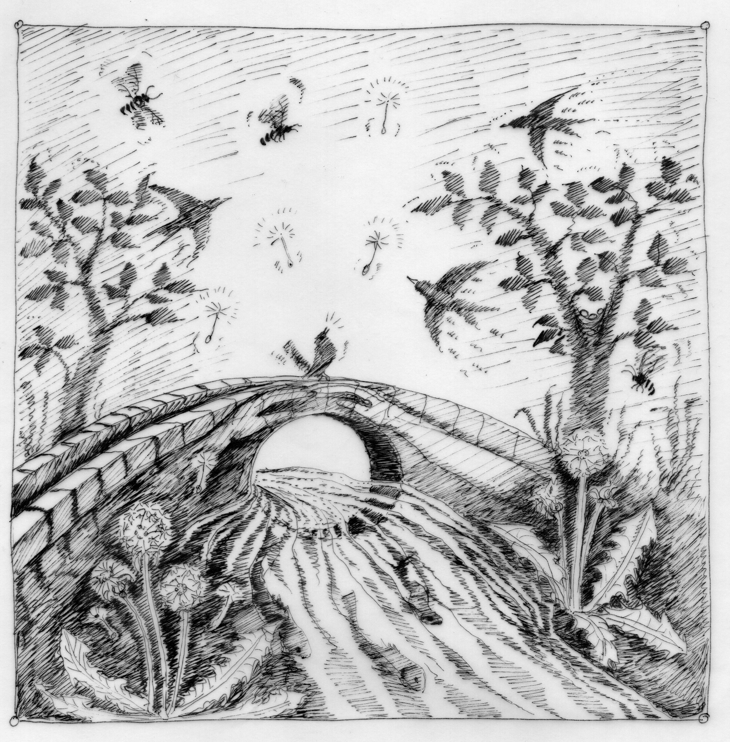

Sunday 24th - Saturday 30th July 2022
Emerson College, Forest Row, East Sussex RH18 5JX

Bridging the River

As you walk along the road of life you may walk through pleasant meadows, along calm seashores or even through dappled woodland glades.

Sometimes, however, you may have to cross treacherous mountain crevasses or tempestuous rivers.

Some of these obstacles can be overcome through sheer determination but sometimes you have to build a bridge in order to cross the river.

A bridge can take many forms; it may be just a branch across a bubbling stream, it may be a rope swaying side to side or it may be built of stone ready to stand the test of time. In many ancient cultures and mythology the bridge was regarded as a powerful and magical symbol of the crossing point between the physical world and other realms.

Bridging the river is an art that requires work and imagination. You may have to collect the building blocks, work with others or even learn new skills before you can start the task at hand.

But a bridge can be built, the river can be crossed and your path can continue on the other side. You may find yourself in a new land - what lies across the threshold?

This year at Lifeways we will be Bridging the River - learning some of the skills required, working with old friends and new to discover what it takes to build a bridge that crosses a river.

Booking Information

Please choose ONE morning workshop and ONE afternoon group, which you imagine you’d be happiest in, for the duration of the conference. Please indicate this choice as well as your second-best choice on the application form with the appropriate number or letter. Every effort will be made to honour your choices.
At Lifeways, we encourage full participation. This ensures you will get the most out of this unique conference as well as possibly experience and contribute to the “extended family” feeling often associated with Lifeways.

Each evening there will be a programme with lectures and entertainment for adults. Babysitters will be available in all family accommodation enabling adults to attend.

Children will be in a crèche or in the camp during the morning and choose ONE afternoon group for the duration of the conference. We offer parent and child groups for the little ones. Children share accommodation with their parents / guardians up to the age of 8. Children aged 9 – 14 stay on the camp. Children’s activities are age-appropriate; please take this into consideration when you book.

Morning Workshops for Adults

Here you can explore the theme of the week through creative study, discussion and hands-on experience.

1. Clowning: Laughter as a Bridge with Vivian Gladwell
“Laughter is the shortest distance between two people.” Victor Borge– Danish Comedian, Pianist and Conductor. Laughter builds the many bridges that reconnect us to ourselves and to others. Through play and clowning we meet what is most human within ourselves - which is the first and biggest step towards discovering the world within and without. A workshop of play and silliness that leaves you looking at life with new eyes.

2. Imagination: The Bridge Between – Writing Creatively with Paul Matthews
Through writing tasks (playful and profound) the flowers and frogs we meet in the garden will lend their images to interpret and express what lives inside us. We will also go indoors, writing in lively response to each other and in quietness.

3. Building Bridges with Basketry with Nick Vane
Craftwork brings our creative imagination into relationship with natural materials through the purposeful activity of our hands. They build a bridge between our inner self and Nature by enlivening our senses and from the warm satisfaction of making something that is both beautiful and useful. In this workshop we shall be learning how to make a useful basket out of natural willow. Suitable for beginners and those wishing to build on existing basic skills. You will be asked for an added charge of £15 to cover material costs.

4. Speech and Eurythmy - The Rainbow Bridge between Heaven and Earth with Geoff and Maria Norris
Ancient wisdom tells us that human beings were created by the words of God. We still experience the mysterious power of words in song, poetry and prose in many languages. In this workshop you may experience an understanding of the deeper meaning of words through speech and the gentle art of Eurythmy - movements which make speech visible to us.

5. The Bridge between the Living and “The Dead” in Wolfram’s Parzival with Andrew Wolpert
We have destiny companions with us here on earth and also among those who have died. Parzival bridges the divide between the Arthurians and the Guardians of the Grail, resolves conflict, and is accompanied by his companions on the other side of the threshold.

6. A Bridge to the Stars: Cosmic Rhythms in Human Life with John Meeks
The quest to discover meaning in the unfolding of our lives has become ever more urgent, as the life-sustaining order in the world around us has begun to falter. In ancient times, the rhythmic movements of the sun, moon and planets seemed to mirror the life of the soul. Even today we can begin to re-discover the subtle ways in which these rhythms establish order in our biographical development. To do so, we will consider the lives of well-known personalities, and try to view them in the light of our own experiences. Weather permitting, a star-walk under dark, moonless skies will also be possible.

Morning activities for Children aged 0 – 8

The following crèches are available each morning from 8.50am – 12.15pm

Parent & Toddler 0 – 3 year olds
Here the youngest Lifeways participants can enjoy a peaceful environment, while parents / guardians can take this special time to observe and connect with their little ones and with each other. There’ll be songs, story, indoor and outdoor play and adults will be guided with making simple crafts for their children to enjoy.

Playcamp 4 – 6 year olds
In this group the children will paint, draw and enjoy simple craft activities. There will be stories, circle games and songs as well as a daily walk and plenty of time for creative play.

Daycamp 7 – 8 year olds
This is a morning group with slightly more challenging crafts and outdoor activities for the older child.

Children’s Camp 9 – 14 year olds
The camp is divided into younger (9-11) and older (12-14) camps, which are right next to each other. Some of the activities are shared and others separated. Morning and evening programmes will include games, crafts, helping with meal preparation, and other activities The campers choose ONE afternoon group for the duration of the conference. Please help your 9-14 year old child to pack a tent, sleeping bag, blanket, towel, good walking shoes, waterproof clothing and boots, swimming gear, old clothes, torch and eating utensils (plate, bowl, cup, knife, fork and spoon). Tents may be shared by children in the same age groups. Please make your child aware that at Lifeways he/she will have a (welcomed) break from mobile phones, tablets, mp3 players, computer games, laser pens or any other electrical devices. Do apply early to ensure your child’s place and remember to fill in their first and second-best workshop preferences as well as meal options on the application form.

Afternoon Groups (*Adults only, ** Children only, ***Adults and Children)

Adults only
A* Life After Life - Crossing the bridge between death and re-birth with Dr Sue Peat & Rev Roger Druitt
Exploring the mysteries of what happens after our death, we can ask how best to prepare for the spiritual journey from life on earth to that in the spiritual word - and back to our next earthly incarnation. How too may we begin to influence this now? Rudolf Steiner gave many spiritual exercises that can help us connect with those who have died in a healthy and positive way - benefiting both ourselves and those who have died.

B* Interactive Holistic Bee-culture and Bee-keeping with Christian Grützmacher
Hands on: we will do maintenance in the existing honey-bee garden, care for the log hive and work on a new hive, so bring your work clothes, gloves and wellies. Hearts on: we will do social and artistic exercises related to bees, as well as contemplative bee observation. Heads on: we will discover the magical realm of honeybee culture through conversation, so bring all and any questions you may have.

C* ‘Inner Portraits’ Painting Workshop with Mary Anne Paterson
Accompanied by the Bridge verse by Rudolf Steiner
‘Between the Past
And the Being of the Future
The present is a moment
A moment as a Bridge ………’
We will reveal our ‘Inner Portraits’ and re-discover an Artist within.
No previous experience necessary all materials supplied

D* Making Magical Models with Robert Byrnes
See, touch, move and make (with ease) models that flow endlessly and transform magically.
You will be asked for an added charge of £5 to cover material costs.

Children only
E** Energetic Outdoor Games for 11 – 14 year olds with Milly Woodrow
Social, energetic, imaginative games played together outside on the lawn.
F** Candle Dipping & Decorating for 8 – 14 year olds with Ted Prestbury
Learning how to create beautiful candles through form and colour.

G** Wet Felting for 8 – 12 year olds with Hellen Williams
From fleece to felt - exploring the wet felting process, creating 2D and 3D works with infinite possibilities.
.
H** Clay Digging & Modelling for 6 – 10 year olds TBC

Adults and children

I*** Ukulele and singing for all ages with Juanna Ladaga
Come and join in with an afternoon singing and playing ukulele - no experience needed.
(Please bring your own Ukulele or state on the application that you would like to borrow one)
J*** Land Art: Building Bridges to the Natural World – for adults and children of all ages* with Arthur Dyer
Working with the elements, welcoming the elementals, prepare to get stuck in! In dialogue with the lush surroundings of Emerson College and drawing inspiration from land artists such as Andy Goldsworthy, we will seek to make visible beauties unseen. We will gather, sculpt and co-create, leaving an offering as a collective gesture of appreciation for this generous earth.
*All children must be accompanied by a parent / guardian.

K*** Build a Bridge with Songs for 5 - 7 year olds with a parent / guardian with Sarka Kubschova
Follow a story with games, craft and singing along to the ukulele.

L*** Pick ’n’ Mix Crafts - for 2 - 6 year olds with a parent / guardian with Katie Zienko
Creative experiences for children and adults.

M*** Stay and Play for 0 - 3 year olds with a parent / guardian with Christina Lines
Play area for children and a simple craft for adults.

Prices
Please book and pay your deposit by Monday 28th March 2022 for our Early Bird Fee. The final payment is due on 4th July 2022.

Adults
Course Fee EARLY BIRD £250
Full Fee £280
Accommodation £90 single room
£75 shared room - in most cases shared accommodation will mean a single room with a mattress on the floor.
£55 camping in your own tent
£30 rent a small tent for 2 people
£20 / person to rent mattress and bedding for camping

All Meals £130
Lunch Only £78

Children Age 0-5 Age 6-8
Course Fee
EARLY BIRD £60 £85
Full Fee £75 £100
*children 0-3 attending parent & toddler go for free as this course counts as an adult course
Accommodation £30 £30
All Meals £53 £74
Lunch Only £38 £58

Camp Age 9-14
(inclusive of all meals and other fees)
EARLY BIRD £250
Full Fee £290

Self catering is not possible if your accommodation is on campus except for those with allergies.
Please note that campers will need to have their adult carer on campus unless they are local (see below).

Financial assistance: If you seriously wish to attend this conference but are prevented because of costs, you may apply to the Conference Secretary for the possibility of assistance. Every consideration will be given to your request. Please send details of the amount you are able to contribute with your booking form.

Local children and adults
If you and your family intend to participate in the full programme, but without accommodation, you can book any time and you are entitled to receive the Early Bird fee.

If places are available, local adults and children can join on a part-time basis for crèches, morning or afternoon workshops. Provided there is space, we will also accept local children aged 9-14 on the camp (without their parents). Please note that we can only accept bookings if you can attend each day of the week.
The costs are:
Adult morning workshop £165 (workshops 1-6 and Parent & Toddler)
Adult afternoon workshop £125
Play and Day camp (morning only) £70
Children afternoon workshop £50
Campers - aged 9-14 (inclusive of all meals and fees) £290

You can send us your booking form at any time and we will put you onto the waiting list. We will confirm bookings for local children and adults as well as part-time participants after 7th June. No Early Bird fees. No booking needed to attend evening lectures.

Arrival
Registration is on Sunday 24th July from 2.30–5.00pm. At 6pm we’ll meet in Ruskin Hall for a short welcome before we’ll make our way to supper; the conference opening (adults only) is at 8.15pm. The camp children will set up their tents in the afternoon and will have their own programme. Babysitters will look after the younger children (please request on the booking form / no charge).

Departure
Saturday 30th July after lunch (around 1.15pm). It is not possible to stay longer on campus as we have a new group arriving.

Daily Schedule Monday to Friday
Special programme on Saturday with “Harvest of the Week” and an exhibition.
am | 7:00 – 8:00  Breakfast | 8:15 – 8:45  Community Singing | 8:50 – 12:10pm  Morning Workshops and crèches for children | 12:45  Lunch
pm | 2:30 – 4:00  Afternoon  Groups for adults & children | 4:00 – 4:30  Tea on the lawn / tuck shop with ice cream | 5:00 – 6:00  Market Place:  sharing our life ways / puppet shows on 2 afternoons | 6:15  Supper | 8:15  Evening programme for adults only

Please bring your musical instruments, poetry, drama and any other talents so that we can create an evening event together. Babysitters will be on duty free of charge in family accommodation from 8-9.45pm (please pre-book and make sure that your children are in bed by the time you leave for the evening programme).

Meals
All meals are prepared at the college. They are vegetarian with a vegan and gluten free option (please pre-book). Most of our produce is biodynamic or organic, locally sourced and grown in our own vegetable garden and from Tablehurst and Plawhatch, the neighbouring farms.

Smoking
Smoking is not permitted inside college buildings or campus accommodation. An outdoor smoking area is available.

Please bring a torch, a drinking bottle, wet weather clothes and soft indoor shoes.

Covid 19
If you have questions regarding Covid rules, please contact yvette.dellsperger@emerson.org.uk. Emerson College follows the rules and regulations as issued by the government. If you travel from abroad we advise you to check the official government website on entry requirements from your own country and the UK. Unfortunately, we are not able to offer accommodation before the start of Lifeways for those you need to quarantine on arrival into the UK. For more information see:
https://www.gov.uk/guidance/travel-to-england-from-another-country-during-coronavirus-covid-19
https://www.gov.uk/guidance/how-to-quarantine-when-you-arrive-in-england

Lifeways is organised by Florrie Cassell, Louis Lines, Yvette Dellsperger, Sue Peat and Ted Prestbury.
Cover Design by Vija Docherty Conference Secretary Naamah Pinkerfeld

Emerson College, Forest Row, East Sussex RH18 5JX, England Telephone: +44 (0)1342 822238
Email: naamah.pinkerfeld@emerson.org.uk Website: www.emerson.org.uk

