LEVEL 3 HOLISTIC BABY AND CHILD CARE DIPLOMA
Starting 30 September 2023

Open to EU and NON-EU citizens

A “blended” course, with online teaching as well as residentials at Emerson College and face to face meetings at Rudolf Steiner House, London.

Important: because of its modular distance learning character, this course is now open to EU and NON-EU citizens (see VISA section in the Info Pack). However, all applicants need to attend at least 80% of the full timetable and complete all the assignments to receive the Level 3 Diploma.
Applicants applying from abroad can gain written approval from the course leader not to join the course for the day events at Rudolf Steiner House, but they will need to attend at least 80% of the full timetable to pass the course. Recordings and tutorials will provide necessary information. Your particular circumstances will be discussed with the registrar and course leader.
Uniquely the Holistic Baby and Child Care qualification synthesizes Steiner Waldorf international Birth to Three training guidelines, a practical introduction to the Pikler approach, and the UK government’s Early Years Foundation Stage requirements. The course is led by Dorothy Marlen, a Steiner early childhood teacher and Pikler pedagogue. Sam Greshoff and Silvia Lauzzana, the other main tutors are leading lights in the Steiner early childhood movement in the UK. The course is quality assured and certified by the Crossfields Institute and the qualification has been designed to meet the requirements of the government’s criteria for Early Years Educator (Level 3) qualifications for carers of children from birth to five, released in July 2013, whilst distinctively offering a birth to three emphasis.
The course is approved by the Steiner/Waldorf Fellowship in the UK and the International Association for Steiner Waldorf Early Childhood (IASWECE).

Please join us on this groundbreaking course!

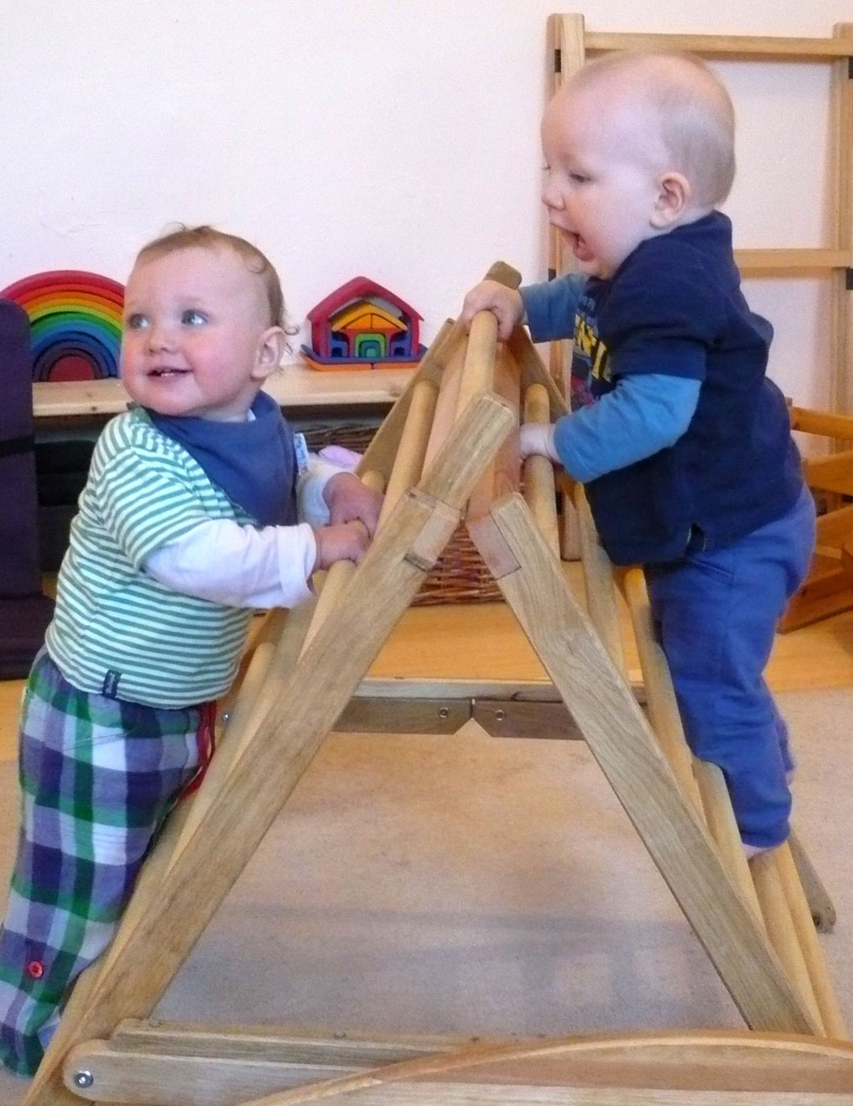

“I will always be grateful for this course which has nourished and inspired me more than I can say. I feel very well set up to follow my dreams. It has been a privilege to learn from and be so supported by each of the tutors. Thank you” A Attwell 2021.

An Introduction to the Holistic Baby and Child Care course

The programme covers the development, care, play and learning of children up to five years old, with an emphasis on the crucial first three years. It provides depth of understanding and a practical foundation for those wishing to work in Steiner settings and mainstream. The course provides parent and child group leaders, child-minders, play group leaders, parenting course leaders with a unique birth to three emphasis. The training provides a nationally accredited Level 3 Early Years Educator qualification for those wishing to care for children up to five years old in both Steiner and mainstream nurseries and kindergartens. (As a Kindergarten assistant in Steiner kindergartens).

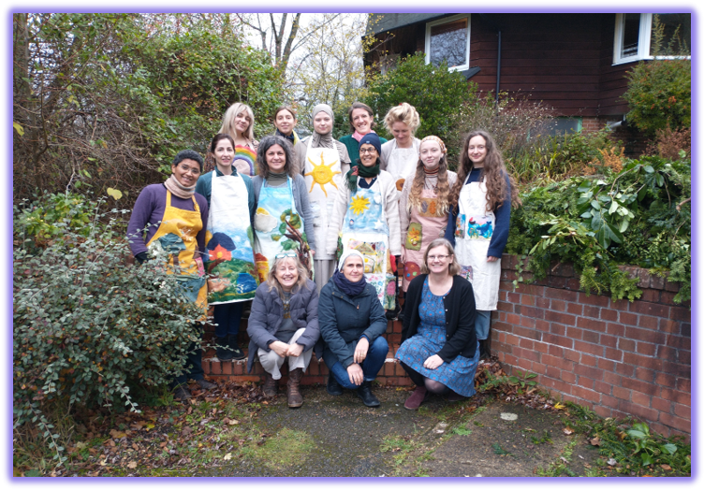
Students and tutors on the last residential 2021 wearing the story aprons students had made.

How is this training different from other Early Years trainings?

As well as fully meeting the criteria required by DfE standards for Early Years Educator qualifications, the training uniquely provides:
• An integrated and detailed understanding of the development and respectful care of children under three
• An in depth understanding of how to enable natural and full gross and fine motor development
• An emphasis on the principles and practice of creating care environments that encourage play from birth to five, as this is the way children predominantly learn
• Hands-on experience in practical and artistic skills, including singing, storytelling, simple puppetry, celebration of festivals and how to create a calm, imitation-rich environment
• “Home from home” and outdoor models of childcare
• A journey in self-development that will confer skills and confidence for caring for children, as well as supporting parents in parent and child groups, parent and baby groups and in other forms of parent support

“The Holistic Baby and Child Care course was like coming home for me. I found the knowledge, community and growth I had been yearning for - a guiding light towards my destiny path. I cannot recommend this course enough to anyone with a calling to work with new families, infants and young children in truly holistic way”. A Cochran 2021

If you are a childminder….

This training will provide you with confidence and practical skills to care for young children. There will be an emphasis on the care of children from birth to three. You will gain confidence to create “home from home” and outdoor settings which respect the young child’s need for warm relationships, a calm and rhythmical day and lots of play. It will give you tools for working with and supporting parents. You will gain an early years Level 3 qualification.

“The Holistic Baby and Child Care course has been the core element of my personal, professional and spiritual development journey during the past two years. The guidance, support and inspiration has been abundant in its accessibility and the skills are invaluable in all areas of life. The range of topics covered considered the diverse needs, interests and purposes of all students and are delivered by extremely knowledgeable and experienced pedagogues”. L Newman 2021

If you are an early childhood professional in a nursery, forest school or day-care setting or wish to develop your own a holistic childcare setting…

In mainstream nurseries and day-care settings, this Level 3 qualification will provide the necessary training required to care for children from birth to five. The advantage of this qualification is that you will bring to your setting a coherent body of awareness and skills based on Steiner pedagogy and the Pikler approach, which will enhance your professional work. We introduce several acclaimed holistic models for childcare including the “home from home” approach from Lifeways North America, Helle Heckmann’s Nokken, and Awhina from New Zealand and the forest school approach.

If you are a parent and child group leader…

As well as preparing you to work as a parent and child/baby group leader in Steiner and mainstream settings, the Level 3 qualification will give you the breadth and depth of skills and confidence to care for young children and support parents in Steiner and mainstream settings, if you so wish. We bring an understanding of pioneering parent and baby groups based on the Pikler approach and outdoor groups.

“This course has been incredibly nourishing for me personally – introducing new skills and practice that I’ll take forward into what ever I do. It has also given a community of like-minded individuals, which I really cherish”. L Chinnery 2021

What does the Holistic Baby and Child Care training include?

Caring for young children and supporting parents requires many skills – a thorough understanding of child development and respectful practical care; confidence in a variety of artistic, craft-making and home-making activities; observational and self-reflective abilities; a capacity for working sensitively with parents and other professionals, and a clear understanding of EYFS, effective child assessment and working with statutory requirements. The units will weave together to provide a firm foundation for continued personal and professional growth and development. Themes covered include:

• An overview of Steiner Waldorf child development up to 21 years
• An in-depth introduction to Rudolf Steiner’s view of child development for the first seven years, with an emphasis on the first three years
• An in-depth introduction to the Pikler approach from Hungary, providing exemplary practical knowledge and skills for respectfully caring for children up to three and the natural unfolding of gross and fine motor skills
• Practical skills including how to plan for play, how to set up indoor and outdoor environments, storytelling, puppetry and activities of all kinds for different ages, especially the under 3’s.
• Comparative child development studies and contemporary educational issues
• Preparation for working with statutory legislation, regulations and inspections
• A journey of self-development, including how to be a good role model for children to imitate and how to deliver quality and respectful individual and group care in a variety of circumstances
• Observation and assessment skills
• Preparation for working with parents in parent and child and other situations
• Preparation for working as a childminder

“This course was really healing for me. A beautiful journey which I’m glad I had the courage to start. I have met wonderful people and learned a lot. I wish more and more people can take this journey and help spread kindness and love all over”. F Khattabi.

Course structure – summary of units

Unit 1 Rudolf Steiner’s principles of Human Development in an Early Years context
Rudolf Steiner’s life and vision
Principles ideas of Anthroposophy
Before birth
Phases of life and childhood
Holistic approaches to supporting the development of the senses

Unit 2 Birth to seven Child development
Focus on Steiner and Pikler
Overview of birth to seven
Holistic development birth to three
Three to five
Five to seven

Unit 3 Comparative studies
Steiner and Pikler educational theories in context of other key educational theorists
Role of neuroscience in understanding child development and behaviour
Attachment theory
Impacts of contemporary issues on early years education and wellbeing of children

Unit 4 Early Years Observation and Assessment
Steiner Waldorf approaches to observation practice
Children’s drawings
Pikler observation techniques
Formative and summative assessment in early childhood education context
Children’s progress and planning next steps

Unit 5 Developing effective and informed Early Years Practice
Language and communication skills
Individual research in an area of interest
Reflective practice—including biography, reflective journal, meditative exercises and verses
Self-care

Unit 6 promoting the health and wellbeing of the young child
Health and well-being in the child – salutogenesis, care of the senses, childhood illnesses
Supporting the health needs of the young child in an early years setting
Nutrition and hygiene
Sleep
Warmth and clothing

Unit 7 Pedagogical arts
Over view of role of pedagogical and therapeutic arts
Art and craft practice
Songs rhymes and stories for different ages including lyre, voice and gesture
Movement games and ring time
Planning and celebrating festivals
The nature table

Unit 8 The heart of care – planning and providing appropriate care and learning
Introduction to Steiner Waldorf pedagogy
The 4 levels of care
The living arts
The lemniscate of care and the nurturing arts
Domestic arts, gesture and the role of imitation
Planning the indoor and outdoor environment
Working with the etheric rhythm
Models of care including home from home, outdoor.

Unit 9 Supporting parents and working in partnership with other professionals
Working with parents
Understanding parental rights. Experiences and cultural pressures
Different roles - childminders, Parent and child group leaders, keyworkers
Running parent evenings classes and courses
Parent communication and parent education
Preparing and supporting children through transitions and significant events in their lives.

Unit 10 Early years issues, policies, procedures and professional practice
Legal requirements and guidance on health and safely
Policies and procedures in the work place
Child protection
Maintaining accurate and coherent records Inclusion, diversity and multi culturalism

Unit 11 Early Years curriculum in the Steiner and Pikler context
Introduction to EYFS statutory requirements in relation to Waldorf principles and practice
Complying with EYFS planning and programmes
Current early education curriculum requirements
Literacy and numeracy
Visits to non-Waldorf settings
Understanding how to assess within current curriculum framework
Current EYFS range of assessment techniques.

Unit 12 Applied skills – Early Years educator role
Pikler approach – its contribution to Early Years educator role
Bringing Steiner and Pikler together into the care of young children
Practice and role of Early Years professional
Tools for next steps

The course units, rather than being given sequentially, are woven together, through out the course. This, we think, helps the various subjects inform and integrate with each other in a holistic way.

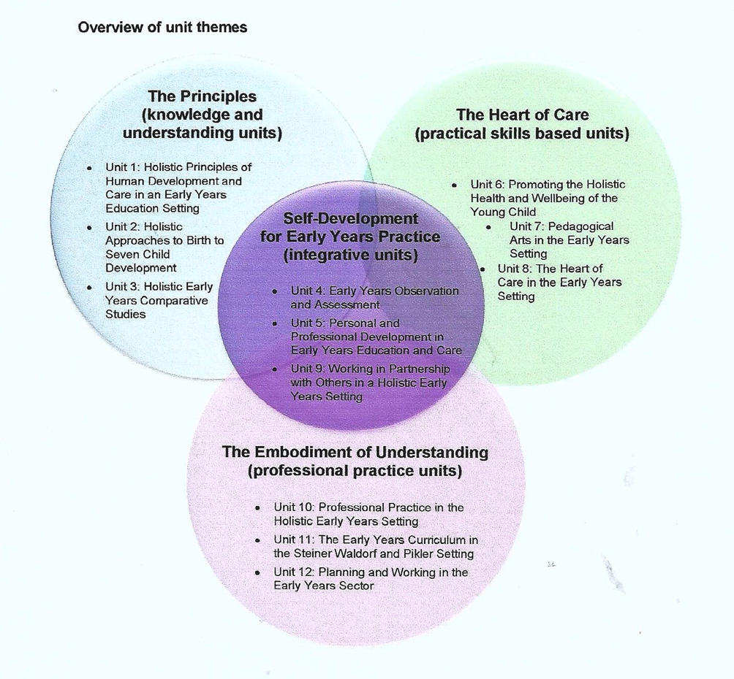

The course venues
Online venue
Emerson College has an online management system and students will be able to access zoom through that. We will use zoom for most of the course teaching. We will meet with you all on-line twice a week – on Wednesdays 7.00-9.00pm and Saturdays 3.00-5.00pm. There will be an attendance registrar and you are expected to attend all sessions. The sessions will be recorded and these will be available afterwards for reference. In addition, there will be pre-recorded videos, handouts and reading materials which you will have access to.
Rudolf Steiner House, London is the main venue for events and trainings based on anthroposophy (Anthroposophy is the system of thought that Rudolf Steiner developed). It is conveniently located near Baker Street Tube station in the heart of London, with various meeting rooms, a library, book shop and café open on Saturday. We will use Rudolf Steiner House for our three face to face Saturday meetings during the course.
See www.rsh.anth.org.uk
Emerson College is located in an Area of Outstanding Natural Beauty in the heart of the East Sussex countryside; it has on-site accommodation and meal provision as well as an extensive range of college facilities on an attractive spacious rural campus near Forest Row. It has a long and distinguished history of providing internationally acclaimed collaborative courses and trainings that explore truly human approaches to global questions. www.emerson.org.uk
The residentials at Emerson College are important part of the course, helping students to become part of a strongly supportive learning community where course content can be deeply explored and experienced together. The residentials have a balance of presentations, practical or artistic work and seminar/group work. There will also be time to enjoy Emerson’s peace and beauty. It is strongly advised that students book on-site accommodation and the full-meal option; it is very much hoped that we can have meal times together as a group. There are two 4 day residentials during the course – starting on a Friday at 4pm and finishing on the following Monday at 4.30pm.
Both venues are wheelchair friendly.
Accommodation and Meals at Emerson College
Emerson College is a friendly, informal Community and welcomes people of different ages and backgrounds from all over the world. Single rooms are available and are equipped with a single bed, desk, lamp, chair and linens. Bathrooms and showers are shared. Accommodation can be booked through the Emerson websitehttps://emerson.org.uk/events/ . Additional information about accommodation can be found on our web site at https://emerson.org.uk/our-venue/our-accommodation-food/

Course dates
The course starts on Saturday 30 September 2023 online and finishes on 2 December 2024 at Emerson College.
In total there will be 3 full day meetings at Rudolf Steiner House, 9.00-6pm (30 September 2023, 13 Jan 2024, 14 September 2024).)
Two 3-day residentials at Emerson College on 7th to 10th June 2024 and on 29 November to 2nd December 2024, starting Fridays at 4.00 and finishing on the following Monday at 4.30pm. There are 34 weeks of online teaching, meeting on Wednesdays 7.00-9.00pm and Saturdays 3.00-5.00pm.
There is no teaching during December 2023, Apri l2024 and August 2024.
Please see attached calendar for the full course dates.
NB Applicants applying from abroad can gain written approval from the course leader not to join the course for the day events at Rudolf Steiner House, but will need to attend at least 80% of the full timetable to pass the course. Recordings and tutorials will provide necessary information.
In the case of a future lock downs, we will put the face-to-face sessions on line where necessary.
Summary of the schedule
Face to Face:
30 September 2023 – 9am-6pm at Rudolf Steiner House
13 January 2024 – 9am-6pm at Rudolf Steiner House
14 September 2024 – 9am-6pm at Rudolf Steiner House
Residentials at Emerson College (they start Friday at 4pm and ends on Monday at 4.30pm):
7th to 10th June 2024
29 November to 2nd December 2024
Online teaching:
It starts on Saturday the 30 September 2023 and then it is twice a week: Wednesdays 7.00-9.00pm and Saturdays 3.00-5.00pm.

Course tutors
The core course tutors have been carefully chosen for their knowledge and experience in Steiner and Pikler Early Years practice in a variety of early years settings. They will take charge of and teach specific aspects of the course with the support of a range of specialist tutors who will bring subjects such as singing, artistic activities, movement and craft work to the day courses and residential.
Core team members are: Dorothy Marlen, Sam Greshoff and Silvia Lauzzana. Several other guest speakers will join us over the course.

Assignments, assessment and validation
There is a schedule of assignments that you will have to undertake to complete the course. On the first course session, you will be given an induction and a study skills session. Support will also be given by tutors during the duration of the course if needed. Assignments include written work, artistic and craft activities and oral presentations. You will also be visited in your work placement.
You will need access to a computer and the internet.
It is suggested that students spend a minimum of seven hours a week reading, studying and undertaking assignments. You will be given a clear and detailed schedule of assignments, and it is important that you keep up to date so that a backlog does not build up. Tutors will be available to offer support and advice throughout the course. Illness, of course, will be taken into consideration and there will be clear procedure for finding the best way forward for the student in these circumstances. Full feedback is given on every assignment so that success and confidence can be built upon over the duration of the course.
At the start of the course you will be given the full course timetable, and there will be detailed timetables provided before sessions online or before days at Rudolf Steiner House, and residentials at Emerson College. You must attend a minimum of 80% from the full timetable in order to be eligible to receive a diploma. You need to complete all the assignments.

Student support
Online Learning
Emerson College has set up ‘Emerson Online’, a new Learning Management System. You will be enrolled on the system before the course starts.
This will hold all the information about the course, including a link to zoom for online teaching, unit information, timetable, recorded sessions, videos, articles, references and assignments. There is also a google drive where you will send your assignments and where you will receive your marked work.
Tutorials
Each student will have a nominated course tutor who will provide general support during the course and there is also a tutor for each assignment. Students can request a tutorial, at any time, to help with assignments or other matters. Special support, for example, with dyslexia can be discussed with your nominated tutor. This may entail using other means of showing that the criteria for any assignment have been met and will vary with different assignments.
There is a course library at Rudolf Steiner House which we have access to.

Work Placements
Work placements (preferably two in different Steiner settings – a choice of kindergarten, nursery, parent and child group and child-minding settings) are an essential part of the course. It is important at the time of applying for the course that thought is given to how such placements can be arranged, if not already in place. It is hoped that the placements reflect your interests and possible future work direction. It is the student’s responsibility to arrange this although we will guide and support you through the process. We know the staff in most of the UK settings and are therefore able to help you contact them and can give you advice about a placement that will work for you. The number of placement hours required is 100 hours, however we are able to be flexible about the way that this can be organised. Students leaving abroad can do their placement in their home country, however please contact Sam Greshoff to discuss this in detail so to meet course requirements. Any questions about placements can be emailed to her as well. She will then arrange to telephone to discuss this in detail and work out a plan that will meet the course requirements and take account of your own situation. Her email address is sam@greshoff.com
You will also be asked to visit and observe in a variety of early years settings. This will be arranged in discussion with each student once the course has started. You will also be asked to carry out short observations of children of different ages. This again will be explained to you once the course begins.

Part time option
Students are expected to complete assignments and the placements by the end of January 2025, therefore receiving your Level 3 certificate in May 2025. This is the much preferred timing. However, if this is not possible for you because of unforeseen life circumstances, there is the option to complete the course assignments and placements by January 2026 (over 2 years). You would then receive your Level 3 later in 2026. Please contact us for further details.

Fee and payment plans

The course fee is £3,150. This includes the course registration with Crossfields Institute, the Steiner Waldorf Schools Fellowship and the Association of Steiner Waldorf Teachers and Educators. (ASWTE).

Payment can be made in full at the beginning of the course or paid in installments with a £100 admin fee.

Bursaries are available from Emerson College.
For the bursary form, please contact Chiara Carones, registrar@emerson.org.uk

Grants for tuition fees are available from the Rudolf Steiner Association. A Grant request can be sent only after having been accepted into the course.
For full info, please contact Chiara Carones, registrar@emerson.org.uk

Interest free loans for tuition fees are available from the Godparents Anthroposophical Training Fund. For full info, please contact Chiara Carones, registrar@emerson.org.uk

Interest free Loans are also available with credit card that offers 0% interest on new purchases. Look online!

Achievement and progression

Successful completion of the course and all assignments will lead to the Level 3 Diploma in Holistic Baby and Child Care (Early Years Educator) (VRQ) (601/5636/3) qualification, certified by Crossfields Institute. The qualification is full and relevant and is on the Ofqual Register of Regulated Qualifications http://register.ofqual.gov.uk.
You can also find the course listed on the DfE-approved qualifications list, http://www.gov.uk/government/publications/eyfs-staffchild-ratios-dfe-approved -qualifications
Learners completing this qualification may proceed directly to work in an early years setting, for example in the role of an early years educator, adult and child group leader, childminder or carer of children up to 5 years, in a Steiner Waldorf or mainstream setting.

DBS Clarification
The Disclosure and Barring Check
An enhanced disclosure check from the Disclosure and Barring Service (there are different rules for getting a criminal record check in Scotland and Northern Ireland) is necessary for anyone working with children in a paid or a volunteer capacity. You should be asked to show your enhanced disclosure check document when you make a visit to any school or setting.
You should also be signed up for the DBS update service.

As the Emerson College Holistic Baby and Child Care course includes work placements, applicants are required to include an Enhanced DBS original document with the application form or to announce their intention of obtaining one before the start of the course. The details on the enhanced disclosure form sent to us will be logged by the Registrar and kept in a secure place.
For more information go to www.gov.uk/disclosure-barring-service-check/overview.

Your DBS must be dated within a year of the commencement of the course. If the form is dated prior to this date, or the applicant does not have a form, one must be applied for.

If you are employed, you will need to obtain the DBS check from your employer.

Alternatively, the setting where you will do your placement can request your Enhanced DBS. Every setting will have their own requirements so please discuss the matter with the setting(s) where you will do your work placement. Please contact Sam Greshoff at sam@greshoff.com if you have any questions.
If you have problems, Emerson College can request it for you for the regular fee.

Applicants are responsible for all the costs of this service.

Please indicate your situation on your application form.

DBS update service
All individuals who apply for a DBS check are now able to subscribe to a government update service. For an annual fee of £13, the update service allows individuals to keep their certificate up-to-date and take it from one role to another within the childcare sector. This enables childcare employers to carry out an instant free online check on the update service of any new information relating to an individual’s record, rather than applying for a new DBS check for the individual. https://www.gov.uk/dbs-update-service

Visas
Because of the Distance Learning Element of the course, applicants from Non-EU countries can join the course with a 6 Months Short Term Study Visa which should be renewed.
For further information, please contact Chiara Carones at registrar@emerson.org.uk

A short introduction to Steiner education and childcare
The first Steiner School was opened in Stuttgart in 1919. Today there are over 1,000 schools and 2,600 kindergartens world-wide, and numbers are continually growing. In Britain and Ireland there are 36 schools.
In many countries Steiner schools are state funded. In England Steiner schools are part of the private sector but there is now a Steiner Academy in Hereford and two public funded schools. Others are planned. This is making Steiner education in the UK accessible to many more families, and as the profile of the education is raised in the UK, the demand for a Steiner-orientated education and care will increase substantially.

All Steiner schools in the UK have several kindergartens for children aged 3 up to Steiner formal school learning age of six to seven. There are also independent Steiner kindergartens and early childhood centres. See www.steinerwaldorf.org

Steiner parent and child groups for parents and their children under three are rapidly growing in number in the UK. These may be attached to schools and kindergartens, or run independently. They provide a calm nurturing setting where parents and their young children can experience many of the unique aspects of the Steiner approach to childcare and family life. There is also now an emergence of parent and baby groups which incorporate the Pikler approach and outdoor groups.

Finally, there is a growing number of Steiner/Pikler inspired or Steiner/Pikler influenced child minders and day care providers who are providing “home from home” day care for children of all ages.

Unique characteristics of Steiner education include:
- Comprehensive all-through inclusive schools which include pre-school, primary and secondary school years
- Education designed to reach the whole child, physically, emotionally, intellectually and spiritually
- An emphasis on the relationship between the pupil and teacher and the social life of the class group
- A curriculum based on a profound understanding of child development reflecting what and how the child naturally learns at different ages
- A schooling experience which is not dominated by continual testing and examinations
- A starting age for formal schooling at age 6/7

Characteristics of Steiner care provision for children under seven – child minding, kindergartens and day care.
Here you will typically find:

- A calm, home-like atmosphere where natural materials predominate, including simple open-ended materials and toys for play
- A regular, predictable, unhurried rhythm that helps children feel secure
- Carers providing high-quality conscious care
- Plenty of meaningful “home from home” domestic and artistic activities undertaken by the adult carers which the children will freely imitate and take into their play
- Time and space for child-initiated play indoors and outdoors
- Plenty of singing, movement, puppetry, storytelling, creativity and imagination
- Seasonal and other special festivals
Rudolf Steiner
Rudolf Steiner (1861–1925) was a scientist, philosopher and a spiritual investigator who focused on bringing his insights into many practical areas of life. Apart from education, including special needs education, he brought new impulses to medicine, agriculture (bio-dynamics), architecture, social therapy, ethical finance, art, drama, movement and others. The system of thinking on which his ideas are based is known as anthroposophy.
For more information about Steiner Waldorf education in Britain, including schools and kindergartens, go to www.steinerwaldorf.org. This site also gives details of available training courses.

For more information about Steiner Waldorf early childhood education and care internationally, go to www.iaswece.org

Emmi Pikler and the Pikler approach
Pikler (1902-1984) studied to become a doctor in the 1920’s in Vienna at a time when many new ideas were emerging. Particularly this was the time when the link between care in childhood and later mental health was realised. Emmi Pikler observed how parents and professionals routinely cared for young children – making them sit, stand and walk before they were ready, and carrying out care routines “to” rather than “with” the child. When her own daughter Anna was born, she and her husband gave Anna the freedom to develop her motor skills at her own pace. Emmi Pikler also applied the principles she had learnt on her medical training about giving careful consideration to all aspects of the care of her child, building an authentic respectful relationship. The results were so convincing that Emmi Pikler applied the principles as a family paediatrician in Budapest to families in her care. She became well known for her excellent practice.
After the Second World War Dr Pikler founded a residential nursery in Budapest for young children. Over the years she proved that children in a home could thrive physically and psychologically by using the approach she had developed with regular families. Careful training of carers, the development of the methodology and meticulous research was conducted over decades. The Pikler approach was very successful – the infants at the Institute were secure, resilient, happy and active.
The Institute’s reputation grew internationally, and videos and publications began to be produced. Training programmes for overseas students were set up as the Institute’s influence became worldwide.
Magda Gerber, originally a parent in Dr Pikler’s family doctor’s practice and subsequently a work colleague took the approach to the USA and started her own movement – Resources for Infant Educarers (RIE). In Germany and now other European countries, and in the USA, the approach has won recognition among Steiner practitioners and has been integrated into nurseries and day care.
Emmi Pikler died in 1984. Since 1992 until a few years ago her daughter Anna Tardos has been director of the Institute. In 2012 the Institute ceased to offer residential care for infants. However, it still offers day care to children and parent and child groups, as well as the training courses for international students.
The Pikler UK Association www.pikler.co.uk
For more information on the Pikler approach www.thepiklercollection.weebly.com

